ST DENNIS PARISH COUNCIL
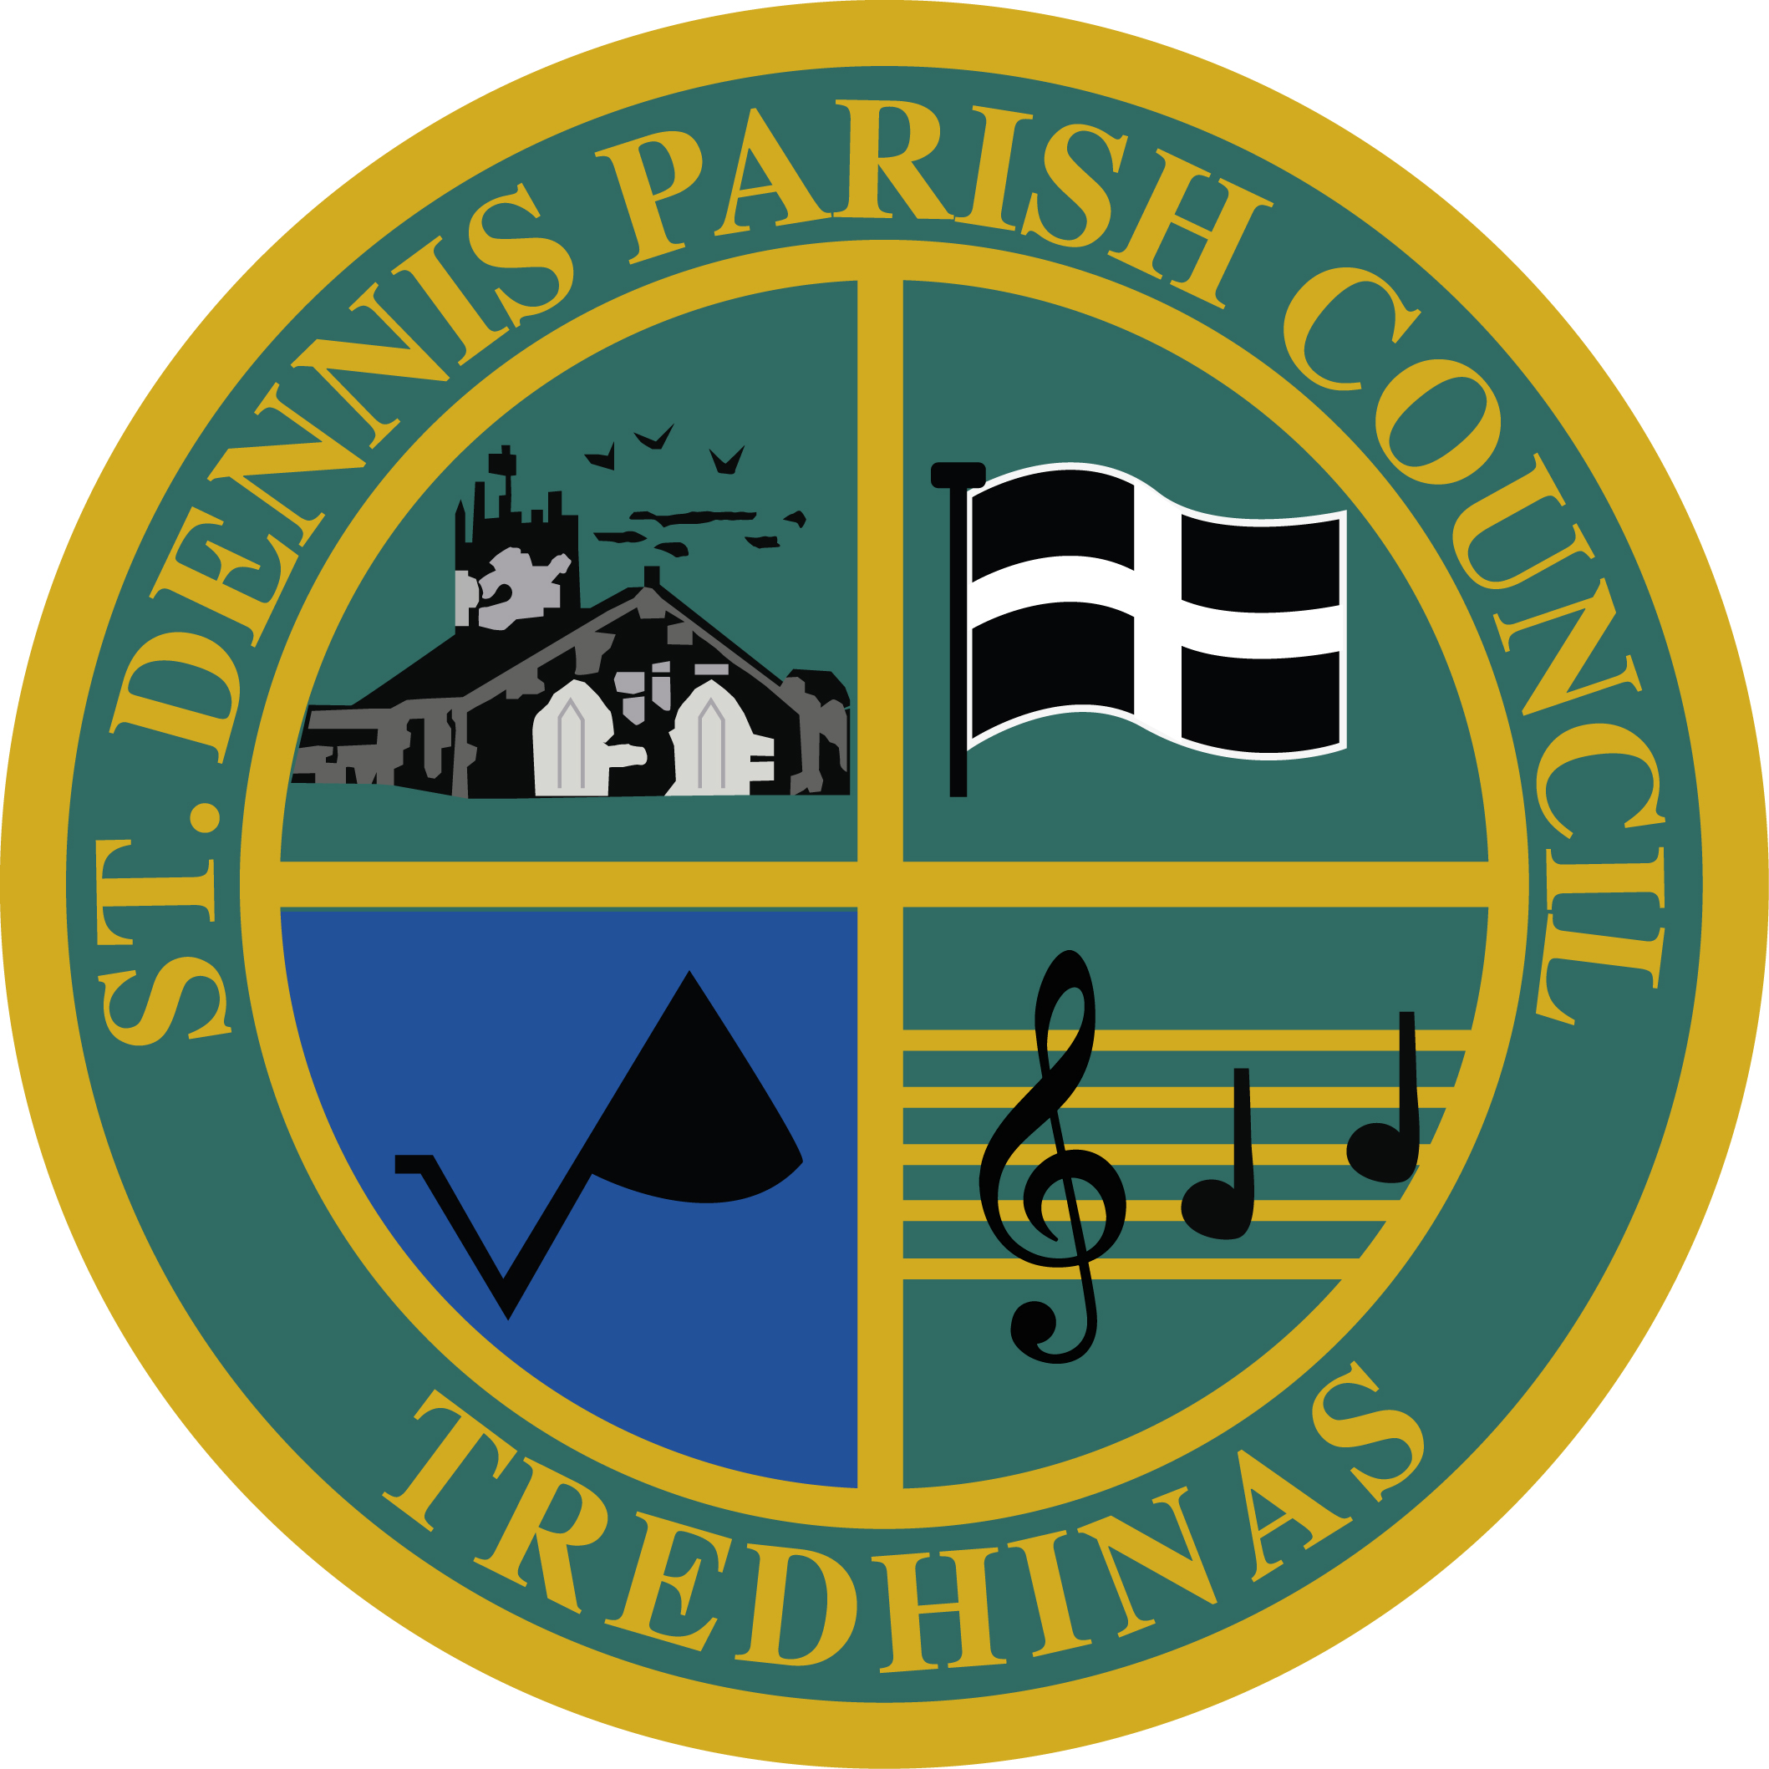

The Claytawc Centre
Fore St Office Telephone No: 01726 821700
St Dennis Email:clerk@stdennisparishcouncil.org.uk St Austell Website: www.stdennisparishccouncil.org.uk
PL26 8AF

WORKING FOR THE PARISH OF ST DENNIS

To Members of Council

Dated: 22nd February 2024

Dear Sir/Madam

You are hereby summoned to attend an Educational Grants Committee Meeting to be held in the Claytawc Centre, Fore Street, St Dennis, PL26 8AF on Thursday 29th February 2024 at 7 pm for the purpose of transacting the following business.

Yours faithfully.

Lynn Clarke

Clerk / RFO

Members of the public are most welcome to attend all Council meetings.

AGENDA

- Apologies
To receive and approve apologies

- Declarations of Interest
a) To receive disclosures of Pecuniary Interests;
b) To receive disclosure of Non-Registerable Pecuniary Interests;
c) To disclose the receipt of hospitality or gifts over the value of £10 and
d) To receive written requests for dispensations on items to be discussed at the meeting.

N.B: If you become aware during the course of the meeting, of an interest that has not been disclosed you must immediately disclose it and request dispensation if necessary.

- Public Participation

- To adopt the minutes of the meeting held on the 28th November 2023 (circulated).

Standing Order ‘3f - Members of the public are permitted to make representations, answer questions and give evidence in respect of any item of business included in the agenda. Standing Order ‘3g’ -The designated time will be 10 minutes and no longer than 5 minutes per person unless directed by the Chairman of the meeting.
- Financials
- Balances as at 31st January 2024.
- Data report on successful applications received from April 2023 - To date.
- To agree the transfer of administration costs to the Parish Council. £303.60.

Standing Order 3e
That in view of the confidential nature of the business about to be transacted, it is advisable in the public interest that the press and public be temporarily excluded, and they are instructed to withdraw’.

- Matters Arising (Information only)
Application 11 – To receive an update on grant spend.

- To agree actions required from an applicant that has not provided receipts.

- Applications for ratification.

- Pending Applications.

- New Applications

- Correspondence received up to time of meeting.

- AOB

This meeting has been advertised as a public meeting and as such could be filmed or
recorded.
Please be aware that whilst every effort is taken to ensure that members of the public
are not filmed, the Council cannot guarantee this, especially if you are speaking or
taking an active role.

